Delta Psi Assembly Minutes:
- Call Meeting to Order at 9:00AM on 04/05/2025
- Opening Ritual
- Invocation – Chaplain Gravert
- Roll Call/Seating of Delegates – Secretary Monson
  - Roll Call Spring 2025
- Approval of Omahas’ Province Minutes – Secretary Monson
  - Beta Nu Assembly Minutes:
- Welcoming of Visiting Brothers
- Officer Reports
  - Satrap Pham:
    - Beta Nu, 2021
    - P4
    - Clinical Interests: Pediatrics/NICU, Oncology
    - Pets: Zoysn
    - Sports team: Cincinnati Bengals
    - Hobbies: Eating Costco Hot Dogs, Riding electric Longboard
    - Updates:
      - Committees: Set up, Continue to sign up!
      - Join the Facebook group and Google group
      - Reach out if you need anything: npp.satrap@gmail.com/Joshpham456@gmail.com
  - Vice Satrap Mensing:
    - Beta Chi, 2021
    - P4
    - Clinical Interests: Critical Care, Emergency Medicine
    - Pets: Lola
    - Favorite Drug: Zosyn
    - Least Favorite Drug: Emagliflozin/Jardiance
    - Updates:
      - Province Planning: Collaborated with Delta Psi, Beta Sigma, and Beta Psi to plan assemblies
      - Led Province Planning Committee Meetings
      - Regent Town Hall:
        - Hosted one, productive conversation with regarding reminders for all chapters and engagement in graduate chapters
  - Secretary Monson:
    - Hobbies: Reading
    - Beta Chi, 2022
    - P2
    - Clinical Interest: neurology
    - Pets: Hera, Lilith, and Theo
    - Favorite Drug: Carbidopa/Levodopa
    - Update:
      - Officer Transitions: Just Update portal! Please check your email
      - Plan to Make transition guide and improve communications
  - Treasurer True:
    - Beta Sigma, 2021
    - P3
    - Pets: Rosie
    - Hobbies
      - Fantasy football, disc golf
    - Updates
      - Savings: $1,917.92 (+$0.06 from interest)
      - Checking: $2,028.13 (+855 from dues obtained today)
        - Debits/withdraws: $1,276.20
          - Website Fee, EC registration, recognition pins, regalia shipment
        - Credits/deposit: $2,408.45 (+855)
          - Dues and Regalia deposits
  - Historian Palkovic:
    - Delta Zeta, 2023
    - P2
    - Clinical interest: unsure
    - Pets: Ham and Opal
    - Favorite Drug: Rapamycin
    - Hobbies: oboe
    - Updates:
      - Sign up for NPP newsletter 
      - Work with graduate and Professional committee to coordinate guest speakers
      - Working with NPP histories to coordinate MASK submissions and chapter reports
      - Send Photos to NPPHistorian@gmail.com
      - Chapter Reports
  - Chaplain Gravert:
    - Delta Zeta, 2021
    - P4
    - Clinical Interest: emergency Med, ID, CC
    - Favorite Sports Team: Cleveland cavaliers
    - Fun Fact: Study materials for pharmacy/nursing students with memory Pharm Study
    - Going to University of Kentucky for Residency
    - Updates:
      - Initiating Cap on Regalia Shipping: $150
      - 2 Grad Ritual Workshops
      - Donate to ROAR
  - Webmaster Mathisen:
    - Delta Psi, 2023
    - P2
    - Clinical Interest: Emergency Med, pediatrics
    - Hobbies: Running, Golfing, Traveling
    - Updates:
      - Follow us on Social Media!
        - Instagram: @kappsinpp and @kappapsi1879
        - Facebook: Kappa Psi- Northern Plains Province (group) and Kappa Psi Pharmaceutical Fraternity
  - Supervisors Reno and Davis:
    - Reno:
      - Cleveland Grad,
      - Cardiology
      - Pets: Ernie and Odin
      - Favorite Drug: Diphenhydramine, Sports
      - Hobbies: travel, Youtube, Vacation planning, home time
    - Davis:
      - Kansas City Grad
      - Favorite sports team: Chiefs, royals, KU everything
      - Hobbies: Sleeping in, yard work, hanging with friends and family
    - IEC Updates:
      - Vision: Leaders in Pharmacy, Excellence in Life
      - MASK:
        - Now going to have specific themes, reduced number of pages
        - Submit to MASK@kappapsi.org. Only annually on July 1st. Photos and in-depth articles are strongly encouraged for all issues
        - New Interim Editor: Brother Melissa Buchanan
        - Now Digital only
        - Sign up via: Kappapsimask.com
      - Portal: Advisors under roles→ Volunteers. Every chapter should each have a faculty advisory and GDC roles completed
        - If GDC/Co-GDC is the faculty advisor: add the role and include the same name as GCD
        - GCD’s will then be asked to complete GCD/Advisor Acknowledgement Form to Specify affiliations
        - If faculty advisor is not on the roster, details should be sent to itdirector@kappapsi.org (Stanley Tan) to create a faculty account for the chapter
      - Plaid Training
        - Tightrope program: REQUIRED for all regents/vice regents
        - Chapter Advisor Training: GCD/Faculty Advisors Required.
        - On Poral
      - Next GCC: Dallas, Texas July 29th-August 2nd, 2026
      - Society 1979: Grads, pay your voluntary dues!
      - Connect with a Grad Chapter
      - Awards
        - Collegiate Chapters complete: https://form.jotform.com/kappa_psi/collegiate-operations
        - Awards due by 6/1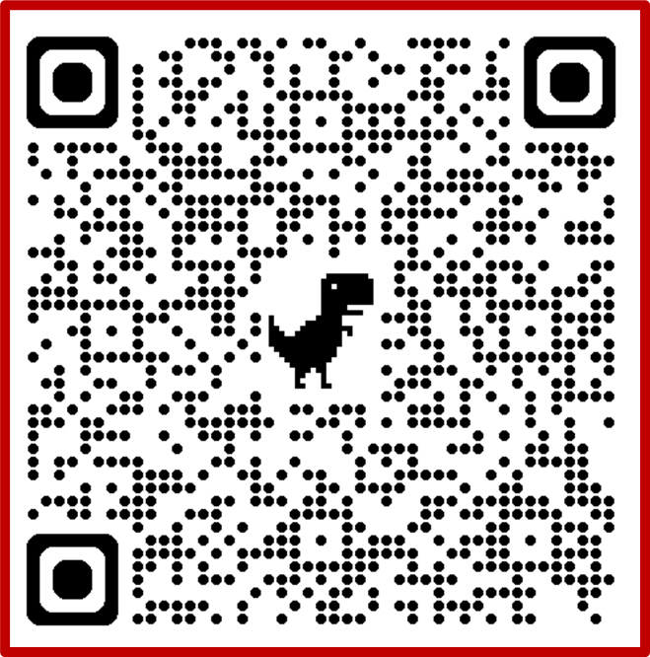 also submit on the Poral!
      - Socials:
        - Instagram: @kappapsi1879
        - Facebook: Kappa Psi Pharmaceutical Fraternity
      - Contacts
        - Central Office at centraloffice@kappapsi.org or call 972-479-1879
        - Grand Regent Miller at grandregent@kappapsi.org
        - Grand Vice Regent Nardolillo at grandviceregent@kappapsi.org
        - Grand Counselor Kabisatpathy at grandcounselor@kappapsi.org
        - Grand Historian Johnson at grandhistorian@kappapsi.org
        - Grand Ritualist Chmil at grandritualist@kappapsi.org
        - Graduate Member-at-Large Hryshko at gmatlarge@kappapsi.org
        - Collegiate Member-at-Large Kreusel at collatlarge@kappapsi.org
        - Immediate Past Grand Regent Milton at imedpastgr@kappapsi.org
        - Executive Director Askew at executivedirector@kappapsi.org
      - Deadlines
        - 2/15/25: Chapter Dues/RM fee (grad and collegiate) were due
        - 3/15/25: Voluntary graduate Dues were due
        - 5/15/25: annual Taxes via File990 (most Chapters)
        - 6/1/25: All Awards due
      - Portal Overview
      - Open Invoices

- Committee Reports
  - Auditing: No Discrepancies found
  - Philanthropy:
    - Reach Out and Read: PhilanTROPHY
  - NPP 99’ers:
  - Legislative and Policy:
    - Starting Policy Manual
    - No updates for Province Ordinances
  - Province Planning:
    - Next Province: Beta Sigma (NDSU)
    - Used Standardized Registration
  - Risk Management:
    - Nothing New
    - Forms were filled out and filed
    - Chapter Reports collected and Look good
  - Collegiate and Graduate Development:
    - Province: Plan to develop the professional development speaker
  - History & Web Presence Committee:
    - Sign up for Newsletter
    - BROTO Challenge
- Chapter Reports
- Old Business
- New Business
- Professional Development Speaker
  - Supervisor Reno/Assistant Supervisor Davis
    - JOIN A COMMITTEE!
    - Reach out to positions you’re interested in
    - Don’t be afraid
- Career Round Tables

Break for Lunch: 11:40 AM until 2:00 PM

- Graduation Ritual
- Resolutions
  - 1. Whereas a venue is essential for conducting province business, be it resolved that the Northern Plains Province thanks University of Minnesota - Duluth campus and the Garden Event Center for the use of their facilities and their staff for the assistance today.
  - 2. Whereas the planning of an assembly requires tremendous creativity, funds, and effort, be it resolved that the Northern Plains Province thanks the Delta Psi chapter and all members who contributed to today’s events.
  - 3. Whereas it takes great time and effort to travel to an assembly hosted by an outside province, be it resolved that the Northern Plains Province thanks our brothers from visiting chapters and provinces for their presence in our assembly this weekend.
  - 4. Whereas the role of an International Executive Committee member is a significant personal and professional commitment, be it resolved that the Northern Plains Province thanks all IEC members for their presence and guidance throughout this meeting.
  - 5. Whereas any province depends on the leadership and support from our supervisors, be it resolved that the Northern Plains Province expresses their gratitude for the contributions and attendance of Supervisor Reno and Assistant Supervisor Davis.
  - 6. Whereas community support for NPP assembly is greatly appreciated, be it resolved that we thank Walgreens and CVS for their Contributions to the Spring 2025 NPP Assembly.
    - Resolutions passed in block
- Announcements
- Adjournment

NPP 99’ers meeting to follow adjournment of session

